User Guide

1. As you open the webpage create an account by clicking on login and then register.

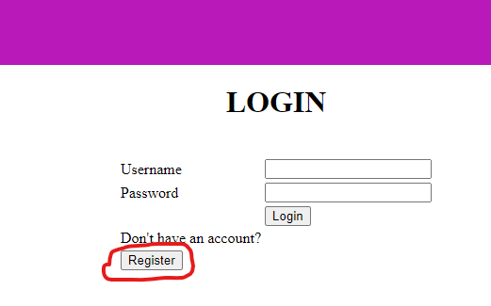

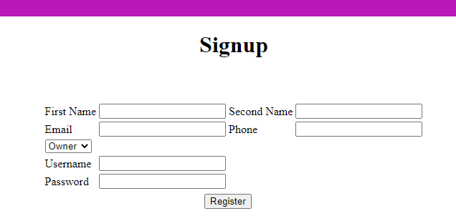

1. Logout the page and re login.
2. Click on home page to start searching or for any general details.

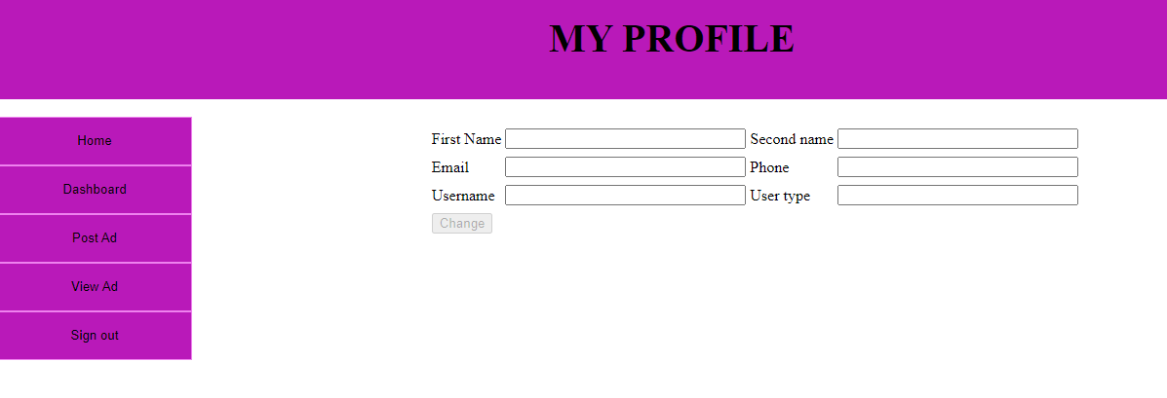

1. You can go back to your account by clicking ‘my account’

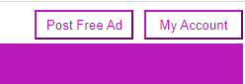

1. Clicking on dashboard gives your account details.

1. Click on post ad for posting your real estate ads

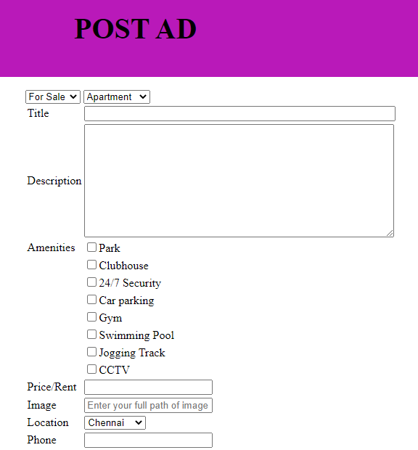

1. Your posted ad and other ads will be visible in View ad page.

